

Project Report
on
AI Powered Brain Tumor Detection System

Submitted by
Aryan Sengar (23csu055)

DEPARTMENT OF COMPUTER SCIENCE AND ENGINEERING,
SCHOOL OF ENGINEERING AND TECHNOLOGY

THE NORTHCAP UNIVERSITY
GURUGRAM-122017

Abstract
Brain tumor detection is an important task in medical diagnostics. Traditionally, diagnosis requires expert analysis of MRI or CT scans, which can be costly and time consuming. This project proposes an AI based brain tumor detection system that automatically analyzes CT and MRI images using a Convolutional Neural Network (CNN).
The system integrates a machine learning model with a hardware interface using Arduino to provide visual indication of results. A Streamlit based web interface allows users to upload scan images through a QR code enabled system. The trained CNN model processes the image and classifies it as either healthy or tumor detected.
The results are displayed through LEDs, LCD display, and servo motor indicators. The system can also generate a detailed diagnostic report and send it via email. Experimental results show that the proposed system achieves high classification accuracy, demonstrating its effectiveness for assisting medical diagnostics.

TABLE OF CONTENTS
Sr. No. | Title | Page No.
1 | Introduction | 4
2 | Problem Statement and Objectives | 5
3 | System Components | 6
4 | System Architecture | 7
5 | Block Diagram | 8–9
6 | Circuit Diagram and Pin Configuration | 10–11
7 | Methodology | 12
8 | Machine Learning Model | 13
9 | System Flowchart | 14–16
10 | Results and Evaluation | 17–18
11 | Advantages and Future Enhancements | 19
12 | Conclusion | 20
13 | Appendix | 21–23

1. Introduction
Brain tumors are abnormal growths of cells within the brain that can affect normal brain function and pose serious health risks. Early detection is essential for effective treatment and improved survival rates. Medical imaging techniques such as MRI and CT scans are widely used to diagnose brain tumors.
However, analyzing these scans requires skilled radiologists and medical experts. This process may be time consuming and expensive, especially in areas where specialized medical professionals are limited.
Recent advancements in artificial intelligence and machine learning have enabled automated analysis of medical images. Deep learning models such as Convolutional Neural Networks have shown excellent performance in image classification tasks.
This project aims to develop an AI based brain tumor detection system that combines deep learning with embedded hardware to create an intelligent diagnostic support system.

2. Problem Statement and Objectives

Problem Statement
Brain tumor detection using MRI or CT scans usually requires expert doctors to analyze the medical images. This process can be time-consuming, expensive, and dependent on the availability of specialists. In some cases, incorrect interpretation of scans may also occur.
To address this issue, there is a need for an automated and intelligent system that can analyze brain scan images quickly and accurately. By using Artificial Intelligence and Deep Learning, medical images can be classified to detect tumors with high accuracy.
Therefore, this project proposes an AI-based brain tumor detection system integrated with hardware components, which can automatically analyze CT/MRI images and provide diagnostic results through visual indicators and reports.

Objectives
The objectives of this project are:
• Develop a CNN model for brain tumor detection
• Train the model using CT and MRI scan images
• Create an interactive web interface for image upload
• Integrate Arduino hardware with the AI system
• Provide visual indicators for diagnosis results
• Generate automated medical analysis reports

3. System Components

Hardware Components Used:
Component | Purpose
Arduino Uno | Main hardware controller
Ultrasonic Sensor | Detects user presence
LCD Display | Displays diagnosis results
LED Indicators | Show risk levels
Servo Motor | Indicates severity level
Jumper Wires | Hardware connections

Software and Tools Used:
Tool | Purpose
Python | Core programming language
TensorFlow/Keras | Deep learning framework
OpenCV | Image processing
Streamlit | Web interface
Arduino IDE | Hardware programming
Tinkercad | Circuit simulation

4. System Architecture
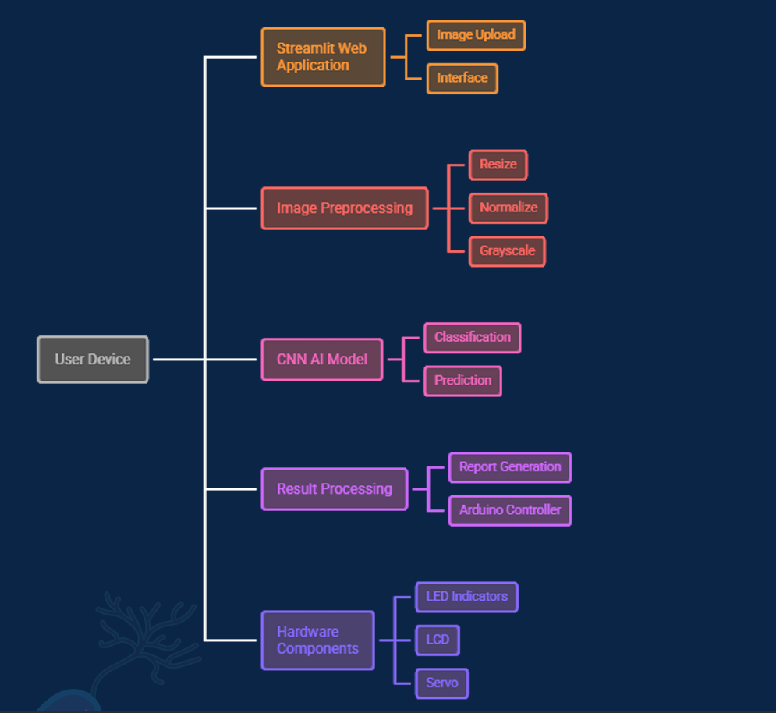
Figure 1 System Architecture

The system consists of three main layers:
1 User Interface Layer
2 Machine Learning Processing Layer
3 Hardware Control Layer
The Streamlit application handles image uploads and communicates with the trained CNN model. The model processes the image and sends the result to the Arduino hardware through serial communication.

5. Block Diagram
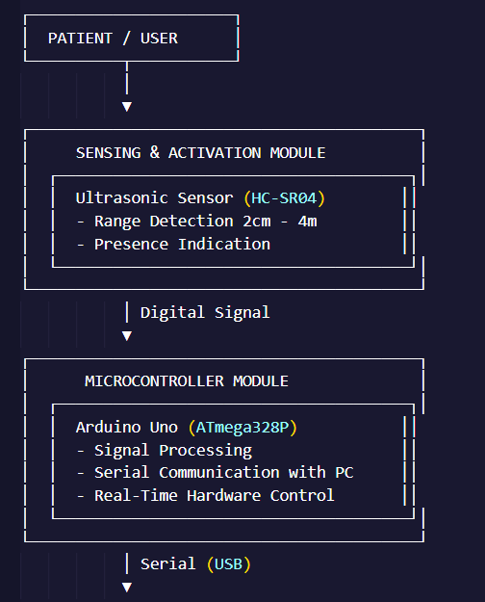
Figure 4.1 Block Diagram

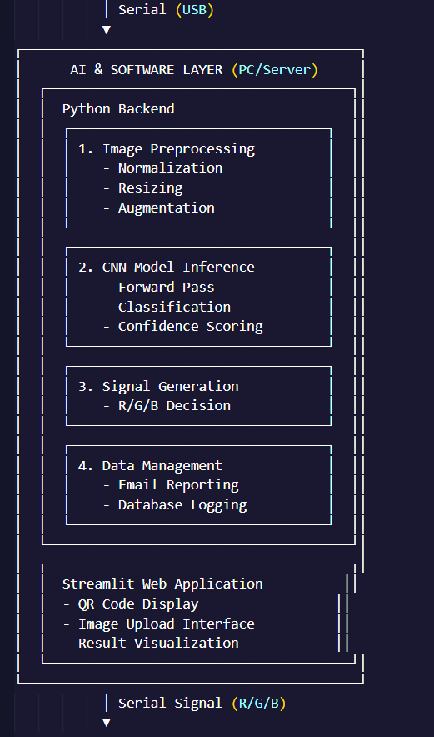
Figure 4.2 Block Diagram
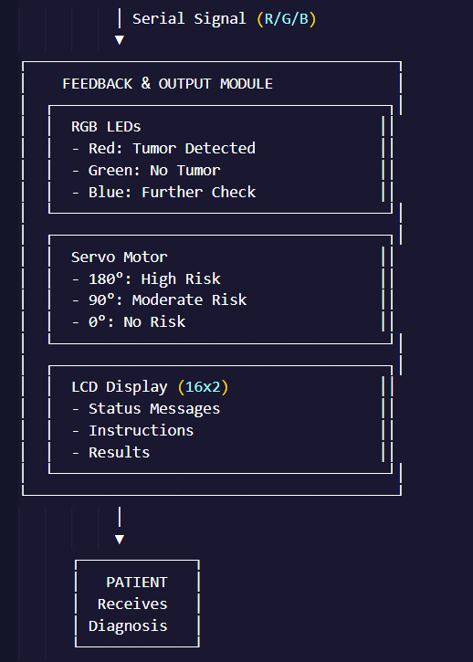
Figure 4.3 Block Diagram

Description
The block diagram illustrates the overall workflow of the system including image acquisition, AI processing, and hardware output generation.

6. Circuit Diagram and Pin Configuration

Circuit Diagram
Circuit Diagram from Tinkercad:
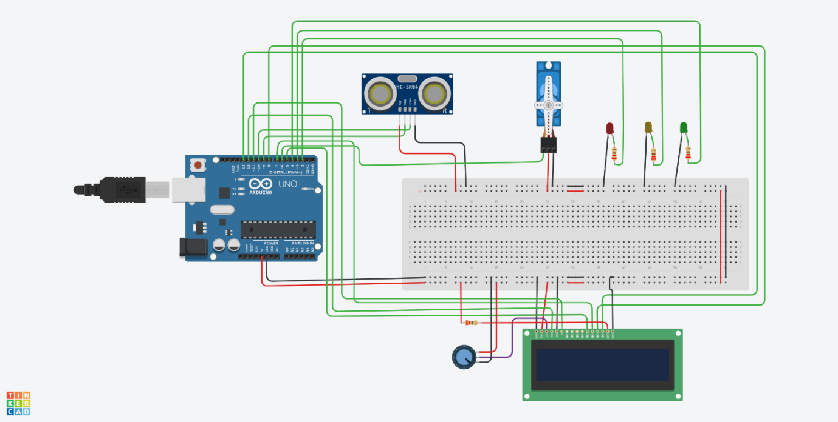
Figure 2 Circuit Diagram

Circuit Description
The Arduino Uno acts as the central controller that connects all hardware components including the ultrasonic sensor, LEDs, LCD display, and servo motor. The Arduino receives signals from the computer system and activates hardware indicators accordingly.

Pin Configuration
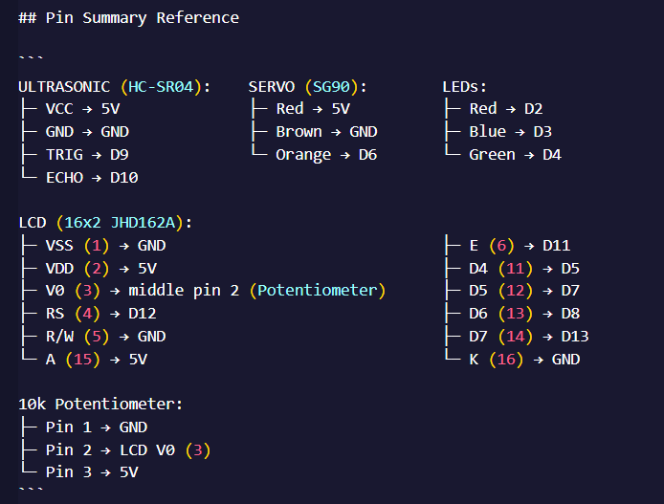
Figure 3 Pin Configuration

7. Methodology
The methodology includes the following steps:
1 Data collection of MRI and CT images
2 Image preprocessing and resizing
3 CNN model training
4 Model evaluation using test dataset
5 Integration with Streamlit interface
6 Hardware integration using Arduino
7 Result display through hardware indicators

8. Machine Learning Model
A Convolutional Neural Network is used for classification.
The model consists of:
• Two convolution layers
• Two pooling layers
• Fully connected dense layers
• Dropout layer for regularization
• Softmax output layer
The model is trained using the Adam optimizer and categorical cross entropy loss function.
brain_ct_mri_classifier

9. System Flowchart
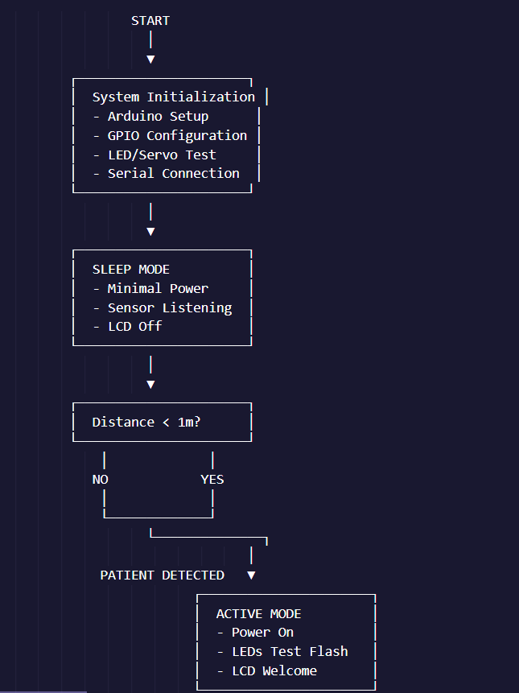
Figure 5.1 System Flowchart

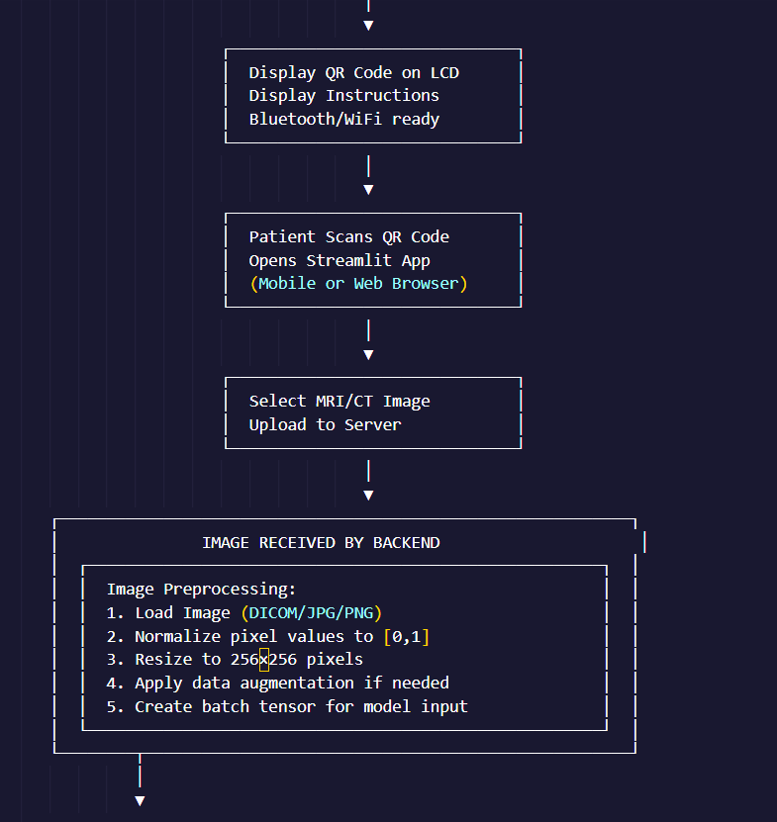
Figure 5.2 System Flowchart
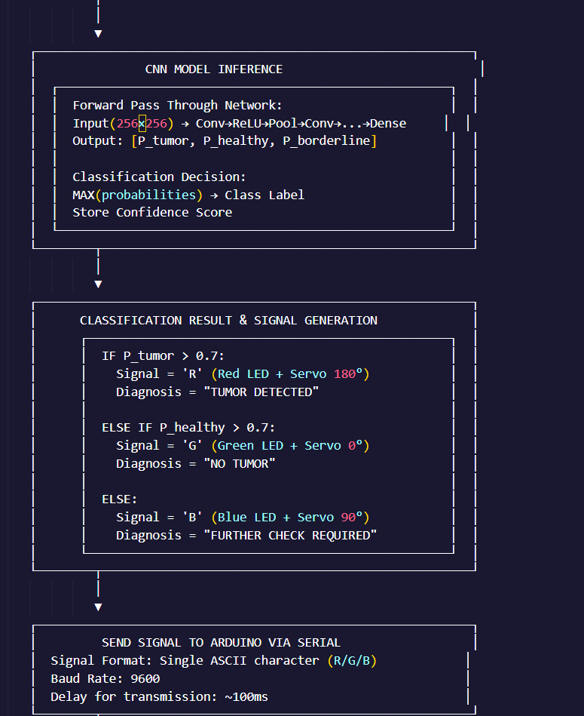
Figure 5.3 System Flowchart

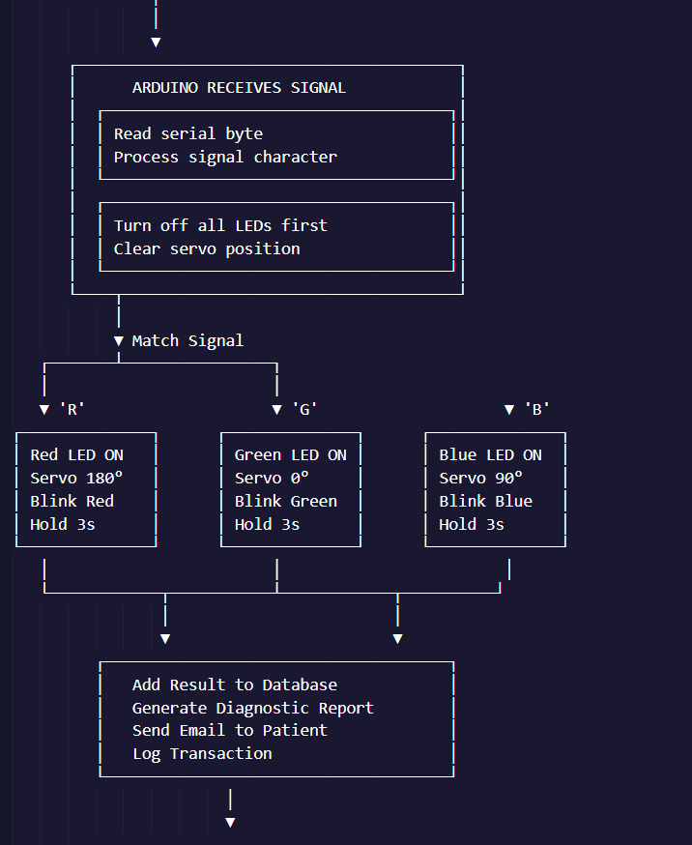
Figure 5.4 System Flowchart
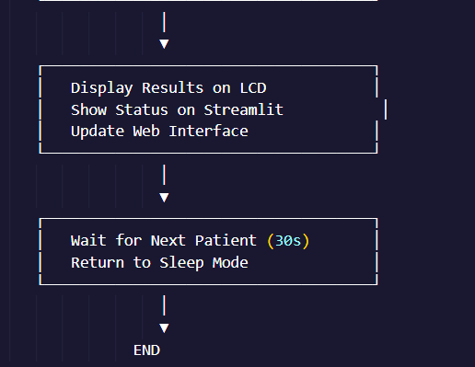
Figure 5.5 System Flowchart

Description:
The flowchart represents the sequential operation of the system from user interaction to final diagnosis output.

10. Results and Evaluation
The model achieved strong performance in tumor detection.
Key evaluation metrics include:
• Precision
• Recall
• F1 Score
• Accuracy

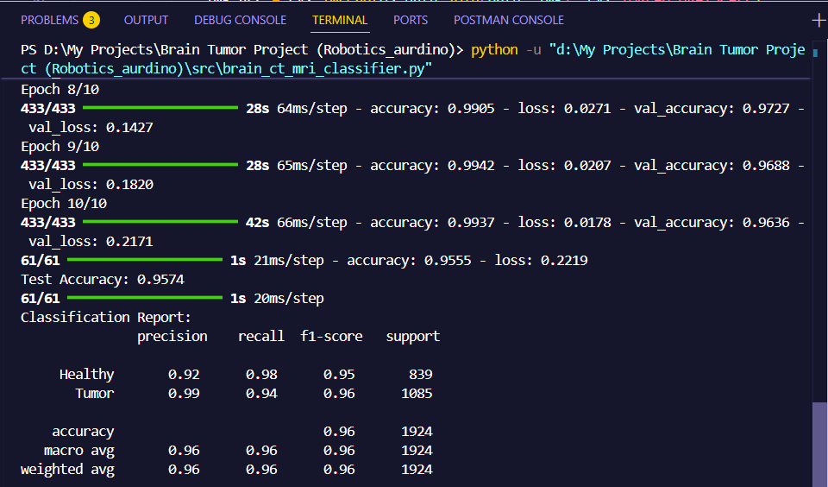
Figure 6.1 Classification Result

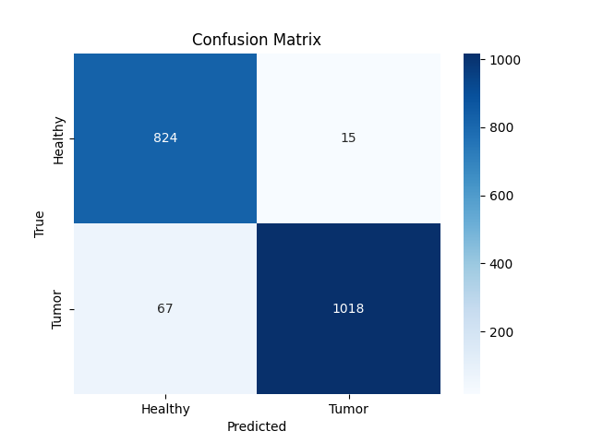
Figure 6.2 Confusion Matrix
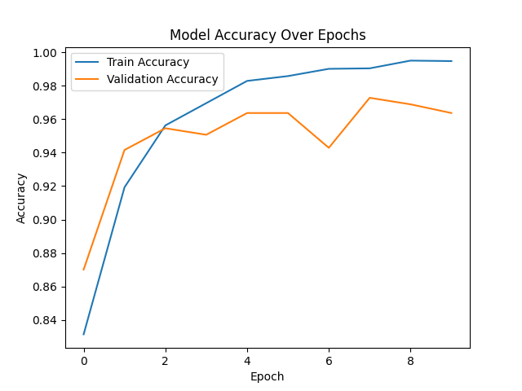
Figure 6.3 Model Accuracy Over Epochs

11. Advantages and Future Enhancement

Advantages
• Fast automated diagnosis
• Low operational cost
• Portable system design
• Easy to operate
• Reduces dependency on expert analysis

Future Enhancement
• Integration with hospital databases
• Training with larger medical datasets
• Deployment on embedded AI hardware
• Multi disease detection capability

12. Conclusion
This project successfully demonstrates the integration of artificial intelligence and embedded systems for brain tumor detection. The developed CNN model can analyze CT and MRI images with high accuracy and provide real time diagnostic assistance through hardware indicators.
Such intelligent systems can support medical professionals and improve healthcare accessibility.

13. Appendix

• Circuit diagram
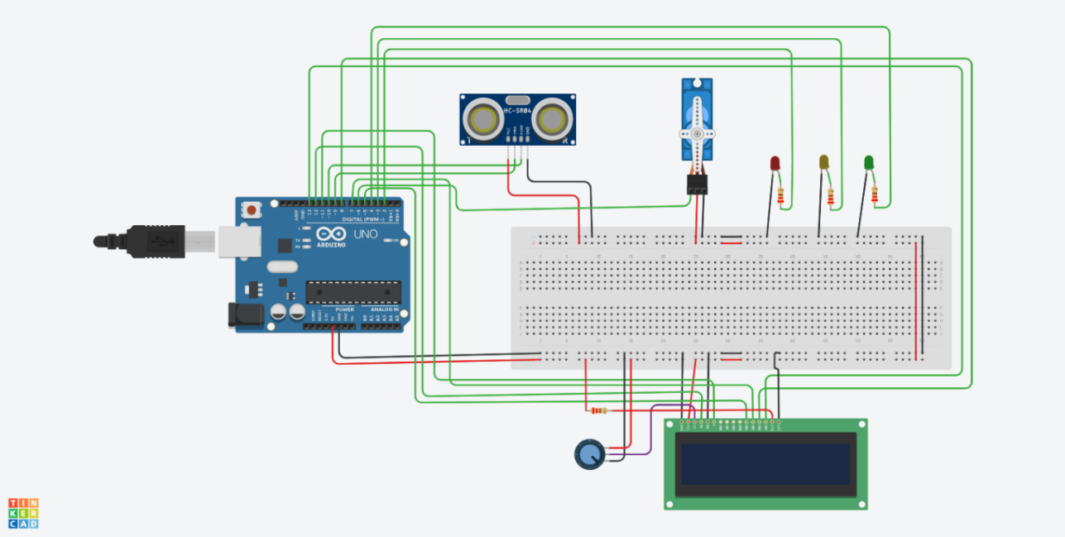
Figure 7.1 Circuit Diagram

• Schematic view
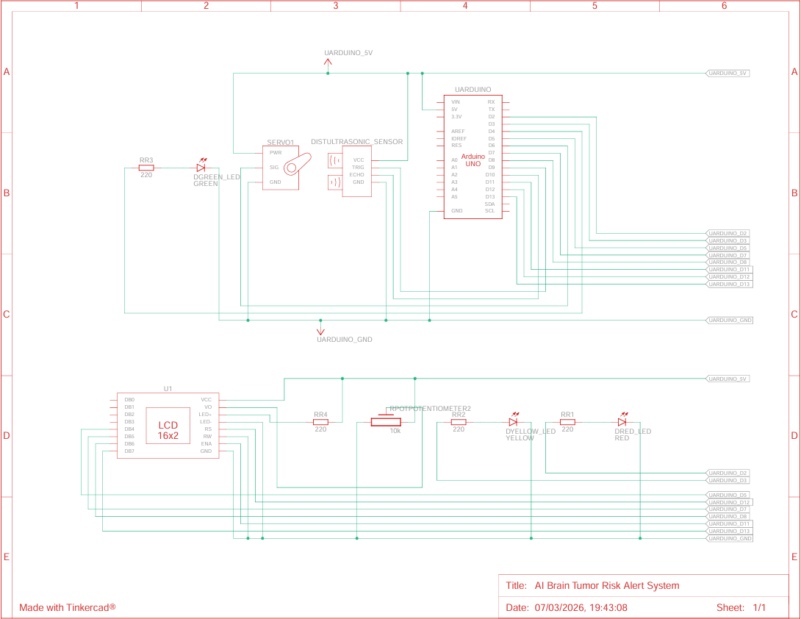
Figure 7.2 Schematic View
- Project Implementation Photograph

Figure 7.3 Project Implementation
• Hardware setup photo
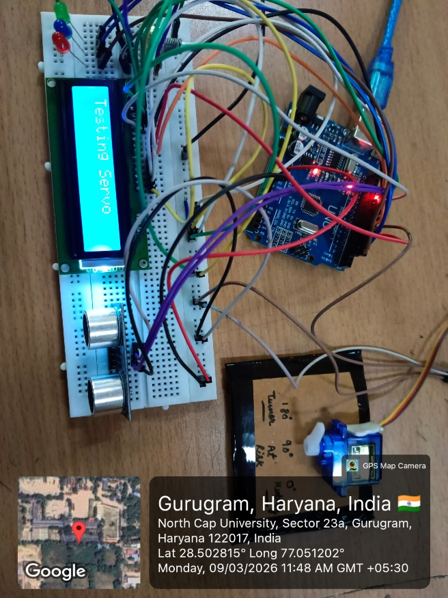
Figure 7.4 Hardware Setup
• VS Code Project File Structure Screenshot
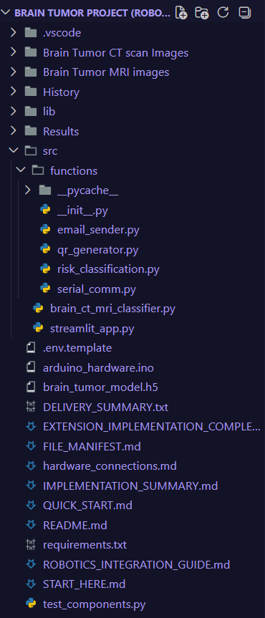
Figure 7.5 Project File Structure

